**Circuit Diagram & Truth Table:**

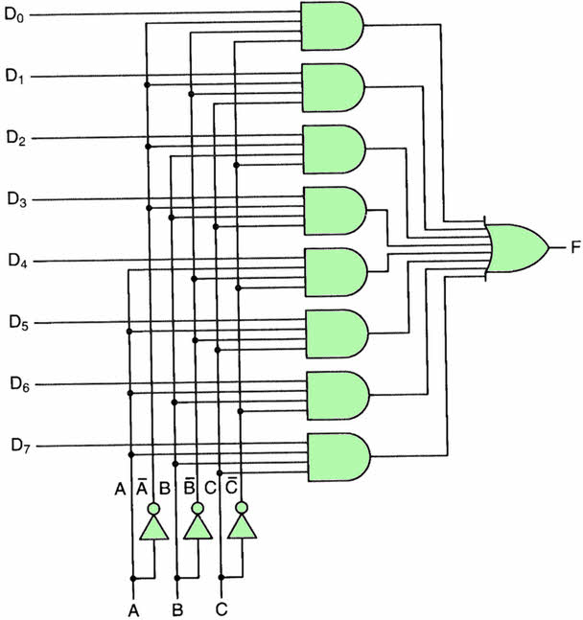

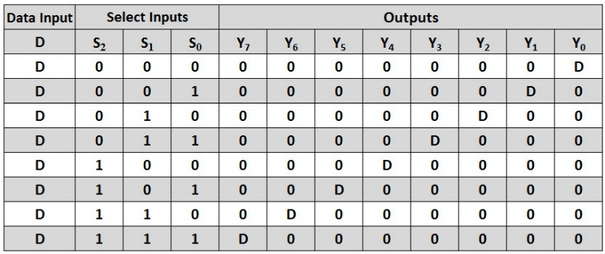

**Code:**

* **Design Module**

module mux(out,a,b,c,d,e,f,g,h,s0,s1,s2);

input a,b,c,d,e,f,g,h,s0,s1,s2;

output out;

reg out;

always @(a or b or c or d or e or f or g or h or s0 or s1 or s2)

begin

case({s0,s1,s2})

3'b000: out=a;

3'b001: out=b;

3'b010: out=c;

3'b011: out=d;

3'b100: out=e;

3'b101: out=f;

3'b110: out=g;

3'b111: out=h;

endcase

end

endmodule

* **TestBench**

module Baig;

reg a,b,c,d,e,f,g,h,s0,s1,s2;

wire out;

mux m(out,a,b,c,d,e,f,g,h,s0,s1,s2);

initial

begin

a=1'b0;b=1'b1;c=1'b0;d=1'b1;e=1'b0;f=1'b1;g=1'b0;h=1'b1;s0=1'b0;s1=1'b0;s2=1'b0;

#30

s0=1'b0;s1=1'b0;s2=1'b1;

#30

s0=1'b0;s1=1'b1;s2=1'b0;

#30

s0=1'b0;s1=1'b1;s2=1'b1;

#30

s0=1'b1;s1=1'b0;s2=1'b0;

#30

s0=1'b1;s1=1'b0;s2=1'b1;

#30

s0=1'b1;s1=1'b1;s2=1'b0;

#30

s0=1'b1;s1=1'b1;s2=1'b1;

#30

$finish;

end

endmodule

**Output:**

